Python Ala-3 GMIU

Python ALA:- 3 Reverse a String:
- Java code:
public class Main {
public static void main(String[] args) {
int a = 48, b = 18;
while (b != 0) {
int temp = b;
b = a % b;
a = temp;
}
System.out.println("GCD = " + a);
}
}
- Python code:

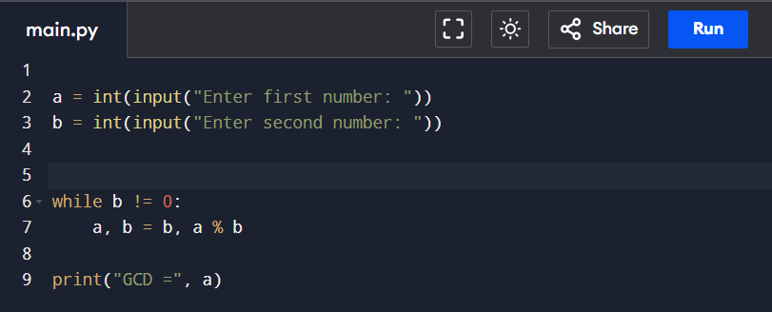
Output:
